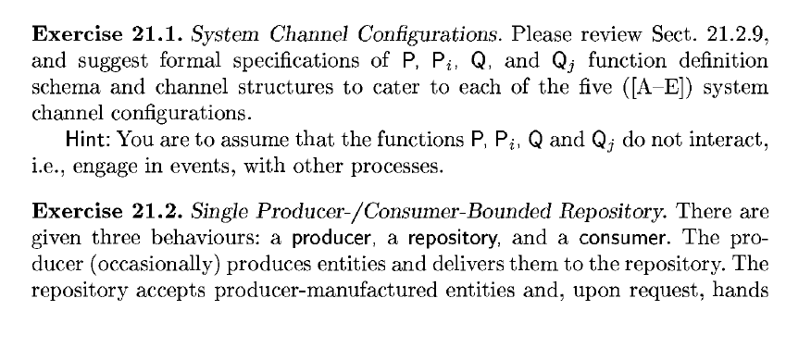

Answers:

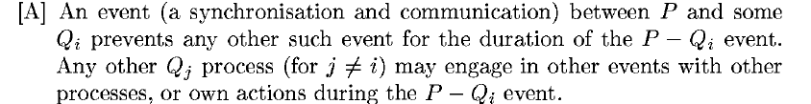

Only permits the event P and Qi to happen, but it wont permit other Q events related to P-Qi. Other Qj events, not related to Qi will be permitted.

Schema:

Type

Channel

Value

DRAWING OF THE CHANNELS

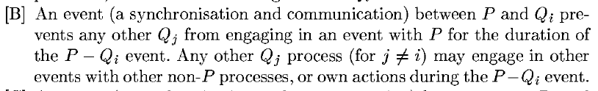

When P-Qi event occurs only Qi may interact with P, any other Qj can interact with other events.

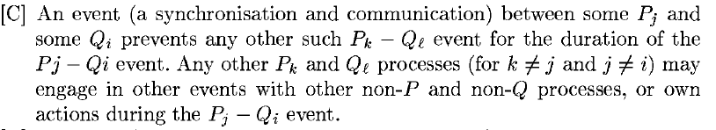

While these two process (any of each ) interact there can not be external interaction with them. The other processes can interact with other external processes.

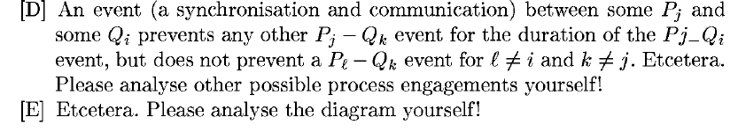

The event Pj -Qi does not permit Pj-Qk but is does permit Pl-Qk. Therefore the first process can only be done one at a time.

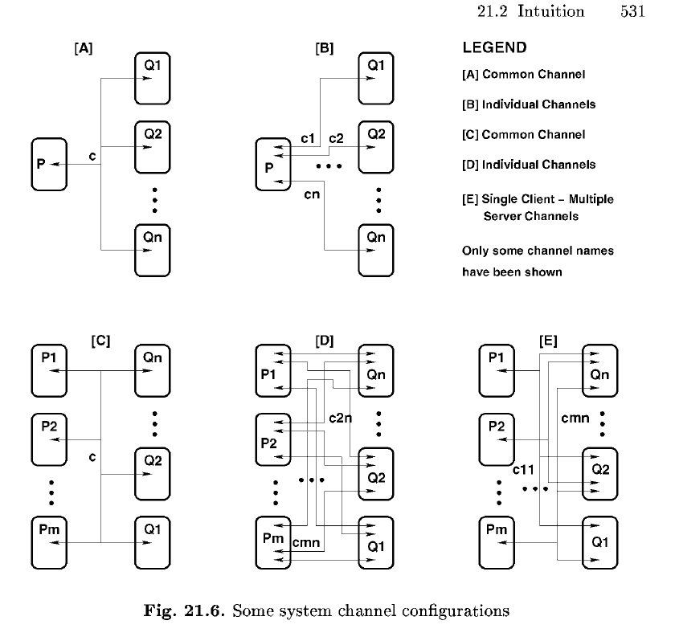

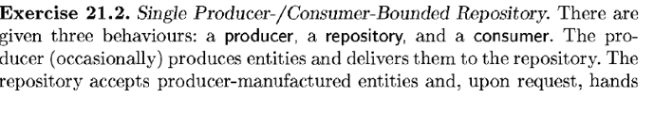

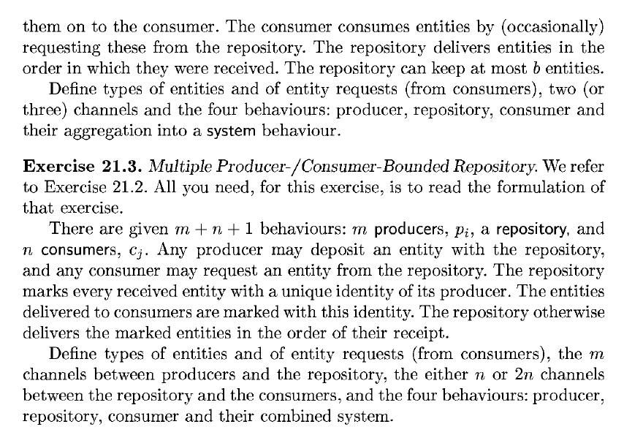

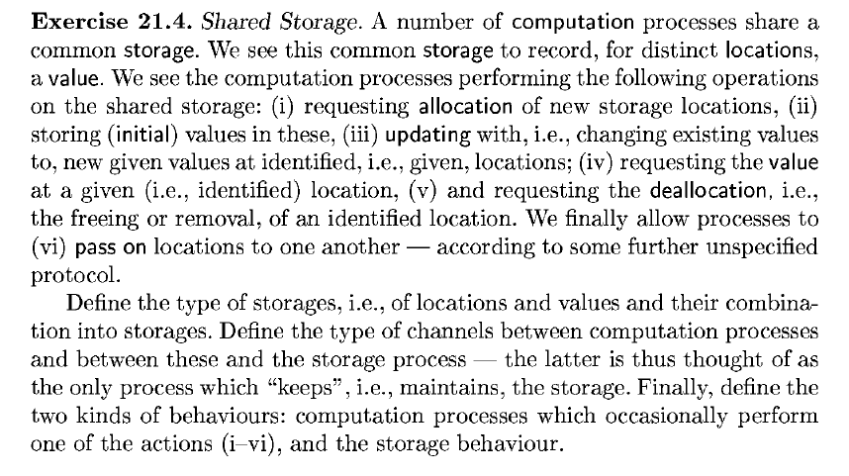

VOL1:CHAPTER 21

1. Entities: Things that we can relate actions to

* See state of balance
* Change state of balance ( deposit, withdraw, etc)

1. Actions can require one or more entities. EX. Withdraw money from one account to the other.
2. Abstraction:
   1. Property-oriented 🡪 algebraic or axiomatic
   2. Model-oriented 🡪 denotation abstraction and computation abstraction.
   3. Operational abstraction 🡪 We focus on, but do not necessarily detail, specific sequence of operations of a system.
      1. Operation abstraction🡪 we abstract individual ( usually basic, primitive)operations over abstracted entities.

Denotation abstraction 🡪 Abstract execution of computer programs.

Operational Abstraction 🡪 When modelling the sequence of actions.

1. Two process share a channel implies they share events.
2. Process🡪 (semantically) means set of traces.
3. Process🡪 (syntactically) function definition.
4. Concurrent processes🡪 set of two or more processes.
5. Global process environment🡪 surrounding with which the process may interact, share in event, BUT EXCLUDING other defined and channel-conducted processes.
6. Process environment🡪 set of other processes and the global surroundings from which the process may receive an input or an output.
7. Event 🡪Process event, the occurrence of an input or an output or both.
8. Externally observable process trace 🡪 sequence of process events.
9. Process Modelling 🡪 We choose to model, in terms of processes and events, phenomena in the real world. In computing when we wish to emphasize concurrently interacting component, that is, how they synchronize and communicate.
10. Component 🡪 STRUCTURED set of values, predicates, functions and operations over these, and events that stand for willingness to “communicate”.
11. Example of Atomic Component – A Bank Account

Values 🡪

* + 1. balance ( cash, a noun)
    2. credit limit ( noun )
    3. interest rate ( noun )
    4. yield ( noun )

Actions🡪

1. the opening of ( verb )
2. the deposit into ( verb )
3. the withdrawal from
4. the closing of an account

Ability to respond to external event ( can be a process)🡪

1. events that trigger the opening
2. “ ” depositing
3. “ ” withdrawing
4. “ ” closing
5. Composite Component – A Bank
   1. Consists of any number of bank accounts
   2. 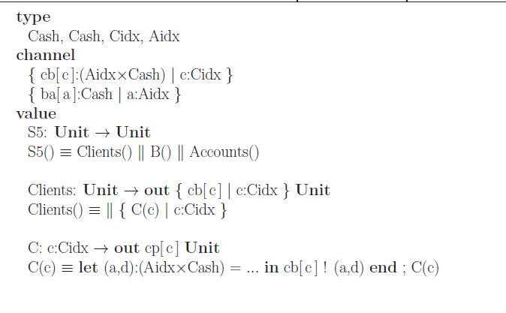Constituent components of bank:
      1. Customers
      2. Bank tellers
      3. 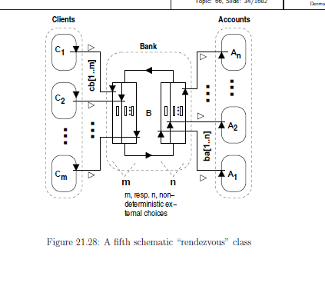Etc

